PROJECT REPORT

SMART HELMET
ELT - 2 - 931

Velammal College of Engineering and Technology
Madurai, Tamil Nadu.

Guided by, Done by,

M. Prabha, M.Tech, M.B.P.Nivetha
Assistant Professor-III M.Karishma
G.Priyanka
M. Seema, M.Tech, N.R.Hemalatha
Assistant Professor-III III year – IT (B.Tech)

TABLE OF CONTENT

1. Introduction ……………………………………………………........... 3
  - Project abstract …………………………………………………. 3
2. Components Required ……………………………………………….. 4
2.1 Arduino UNO Microcontroller……………………………… 4
2.2 Ultrasonic sensor(HC-SR04)…………………………............. 5
2.3 Sound sensor module(FC-04)…………………….…………... 6
2.4 Vibration Motor………………………………………………. 7
2.5 PCB board………………………………….………………… 7
2.6 Jumper wires…………………………….……………………. 8
3. Structure and work of the project……………………………………. 9
3.1 Block Diagram ……………………………...……………… 9
3.2 Circuit diagram………………………………………………... 10
3.3 Construction and Implementation……………………………... 11
3.4 Work Flow…………………………………………………….. 14
4. Source code……………………...…………………………………….... 16
5. Future Enhancement……………………..………………………………21
5.1 Other aspects ..………………………………………………..21
6. Conclusion………………………………………………………………..21
7. Reference…….………………………………………………………......21

1. INTRODUCTION

1.1 PROJECT ABSTRACT

The speech and hearing impaired people may wish to drive motorcycles as a normal person. But they are impotent to drive due to hearing impairment; as a consequence driving license is also not permitted.

We have pitched an idea to design a Smart Helmet which sense the horn and alert the hearing impaired person in the form of vibration. The vibrating motors and ultrasonic sensors are positioned at three sides(Left, Back,Right) of the helmet. The sound and vehicle’s distance is sensed and vibration is generated at the specific side with high probability rate, hence the person gets alert. When such helmet is designed, the hearing impaired people can drive in traffic. Since the license is not permitted to them, they can drive e-scooty. With this Smart Helmet, they get benefitted to drive independently.

2. COMPONENTS REQUIRED

2.1 Arduino UNO Microcontroller

Arduino is a popular open-source development board for engineers and makers to develop electronics projects in an easy way. It consists of both a physical programmable development board (based on AVR series of microcontrollers) and a piece of software or IDE which runs on your computer and used to write and upload the code to the microcontroller board.
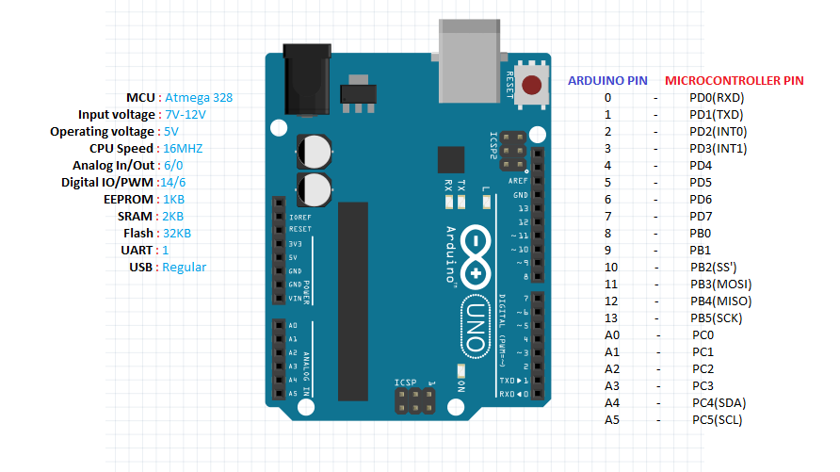

Fig.2.1(a) Arduino UNO

Table.2.1(a) Specification

Parameter | Value
Microcontroller | ATmega328
Operating Voltage | 5V
Input Voltage (recommended) | 7-12V
Input Voltage (limits) | 6-20V
Digital I/O Pins | 14 (of which 6 provide PWM output)
Analog Input Pins | 6
DC Current per I/O Pin | 40 Ma
DC Current for 3.3V Pin | 50 mA

2.2 Ultrasonic sensor (HC-SR04)

The HC-SR04 Ultrasonic Module has 4 pins, Ground, VCC, Trig and Echo. The Ground and the VCC pins of the module needs to be connected to the Ground and the 5 volts pins on the Arduino Board respectively and the trig and echo pins to any Digital I/O pin on the Arduino Board.

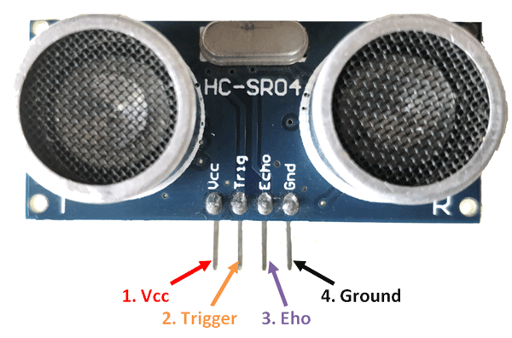

Fig.2.2(a) Ultrasonic sensor (HC-SR04)

Table.2.2(a) Specification

Parameter | Value
Working Voltage | 5V(DC)
Static Current | Less than 2mA.
Output Signal | Electric frequency signal, high level 5V, low level 0V.
Sensor Angle | Not more than 15 degrees
Detection Distance | 2cm-450cm.
High Precision | Up to 0.3cm
Input Trigger Signal | 10us TTL impulse
Echo Signal | output TTL PWL signal
Mode of connection | VCC ,trig(T) ,echo(R) ,GND

2.3 Sound sensor module(FC-04)
This module allows you to detect when sound has exceeded a set point you select. Sound is detected via a microphone and fed into an LM393 op amp.The sound level set point is adjusted via an on board potentiometer. When the sound level exceeds the set point, an LED on the module is illuminated and the output is sent low.

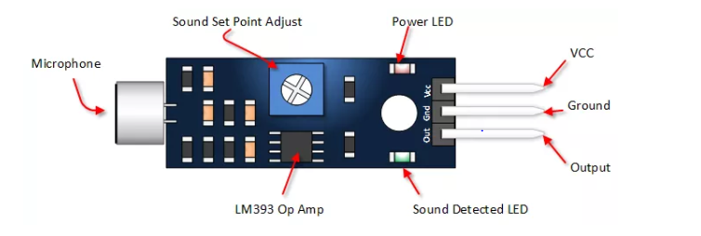

Fig.2.4(a) Sound sensor module(FC-04)

Table.2.3(a) Specification

Parameter | Value
VCC | 5 Vdc from your Arduino
Ground | GND from your Arduino
Out | Connect to Digital Input Pin
Power LED | Illuminates when power is applied
Sound Detection LED | Illuminates when sound is detected
Sound Set Point Adjust | CW = More Sensitive  CCW = Less Sensitive

2.4 Vibration Motor

A vibrator is a mechanical device to generate vibrations. The vibration is often generated by an electric motor with an unbalanced mass on its driveshaft. ... Typically, they are components of larger products such as smartphones, pagers, or video game controllers with a "rumble" feature.
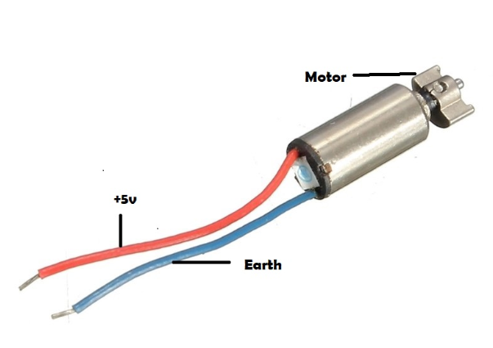
Fig.2.4(a) Vibration Motor

2.5 PCB board

A printed circuit board (PCB) mechanically supports and electrically connects electronic components or electrical components using conductive tracks, pads and other features etched from one or more sheet layers of copper laminated onto and/or between sheet layers of a non-conductive substrate. Components are generally soldered onto the PCB to both electrically connect and mechanically fasten them to it. Printed circuit boards are used in all but the simplest electronic products. They are also used in some electrical products, such as passive switch boxes. Large numbers of PCBs can be fabricated at the same time, and the layout only has to be done once.

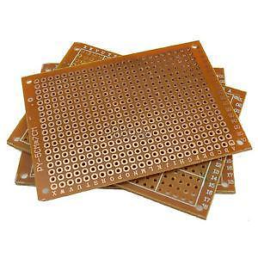
Fig. 2.5(a) PCB board
2.6 Jumper wires

Jumper wires are simply wires that have connector pins at each end, allowing them to be used to connect two points to each other without soldering. Jumper wires are typically used with breadboards and other prototyping tools in order to make it easy to change a circuit as needed. Fairly simple. In fact, it doesn’t get much more basic than jumper wires.

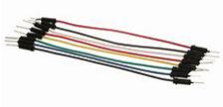
Fig.2.6(a) Jumper wires

Jumper wires typically come in three versions: male-to-male, male-to-female and female-to-female. The difference between each is in the end point of the wire. Male ends have a pin protruding and can plug into things, while female ends do not and are used to plug things into. Male-to-male jumper wires are the most common and what you likely will use most often. When connecting two ports on a breadboard, a male-to-male wire is what you’ll need.

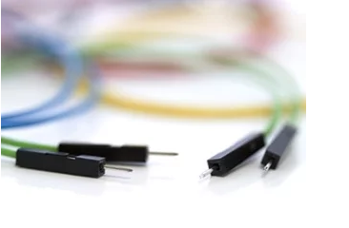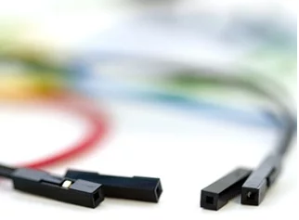
.
Fig.2.6(a) male-to-male Fig.2.6(b) Female-to-Female

3. STRUCTURE AND WORK OF THE PROJECT

3.1 Block Diagram

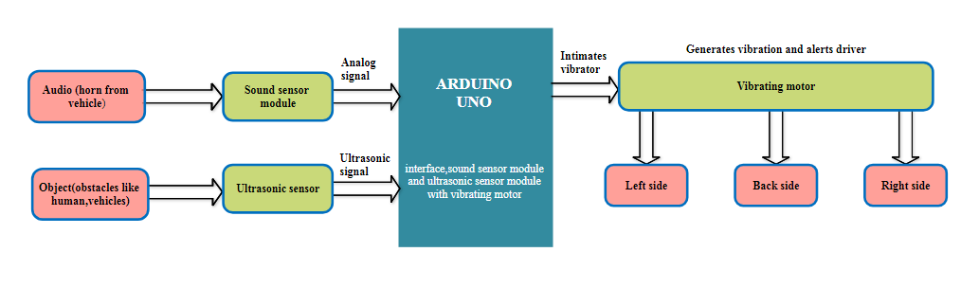

Fig.3.1(a) Block Diagram

Explanation

The block diagram represents how smart helmet woks. The sound sensor and ultrasonic sensor are used through which any obstacles or audio can be sensed by the hearing impaired people. The sound is travelled through arduino UNO which is connected with sound sensor and ultrasonic sensor.It is then given to the vibrating motor . The vibrating motor is fixed in the three sides (left,right,back).If sound or obstacles is sensed then it produce output in the form of vibration.

3.2 Circuit Diagram

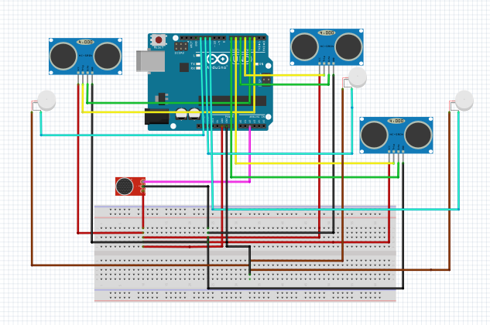

Fig.3.2(a) Circuit Diagram

3.3 Construction and Implementation

Step 1: Connect all three ultrasonic sensors.

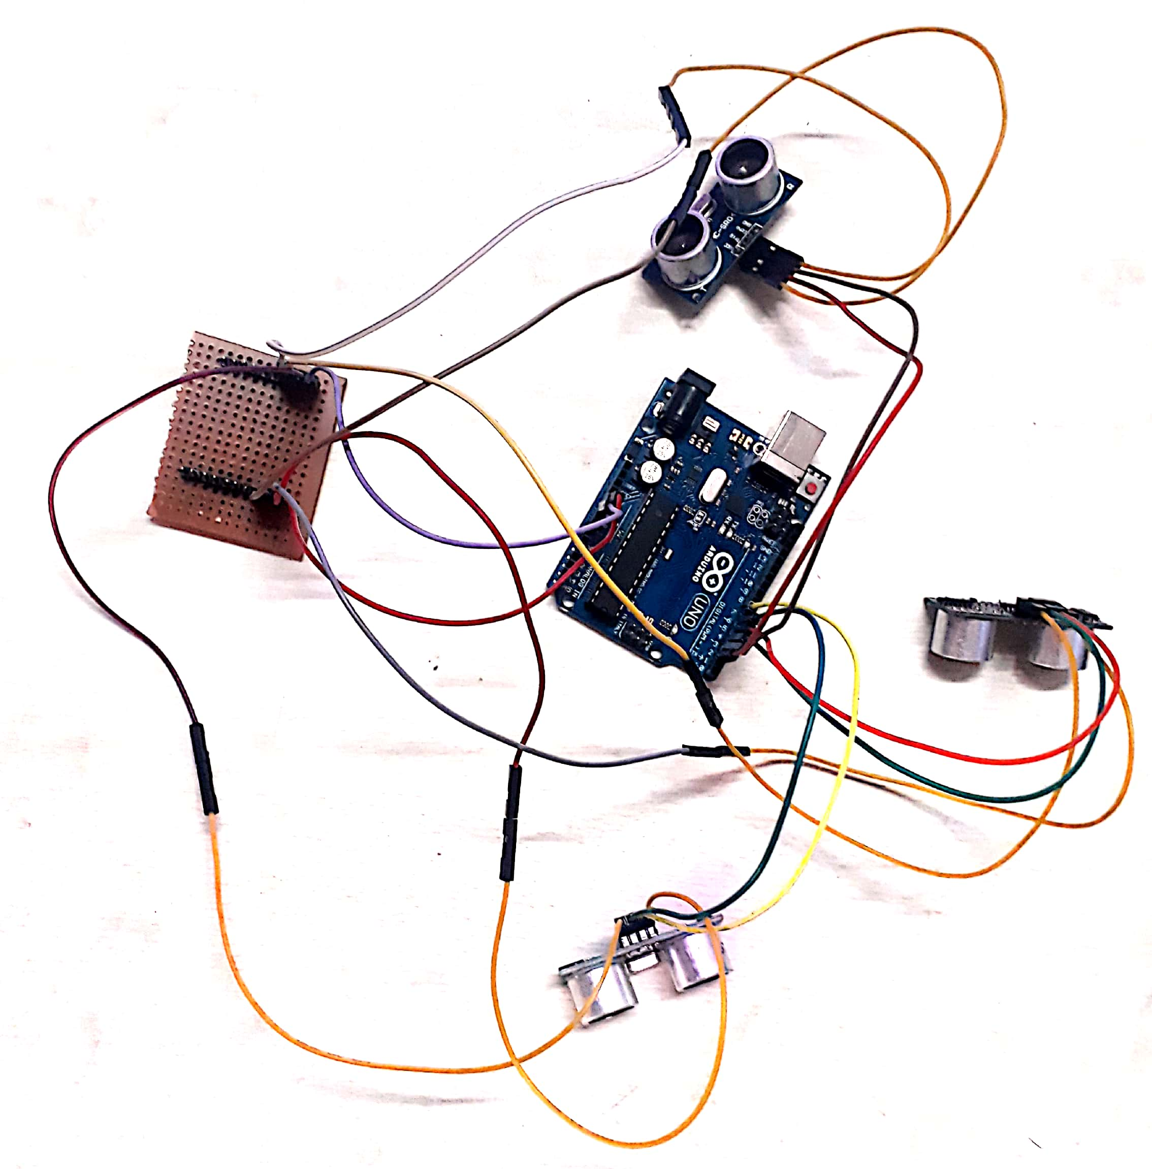

Construction

Common connections : Ground pin connection
5V pin connection
Ultrasonic Sensor 1 connection :

Echo pin1 = D2 Trigger pin1 = D 3

Ultrasonic Sensor 2 connection :
Echo pin2 = D4 Trigger pin2 = D5

Ultrasonic Sensor 3 connection :

Echo pin3 = D6 Trigger pin3 = D 7

Step 2: Connect the sound sensor module

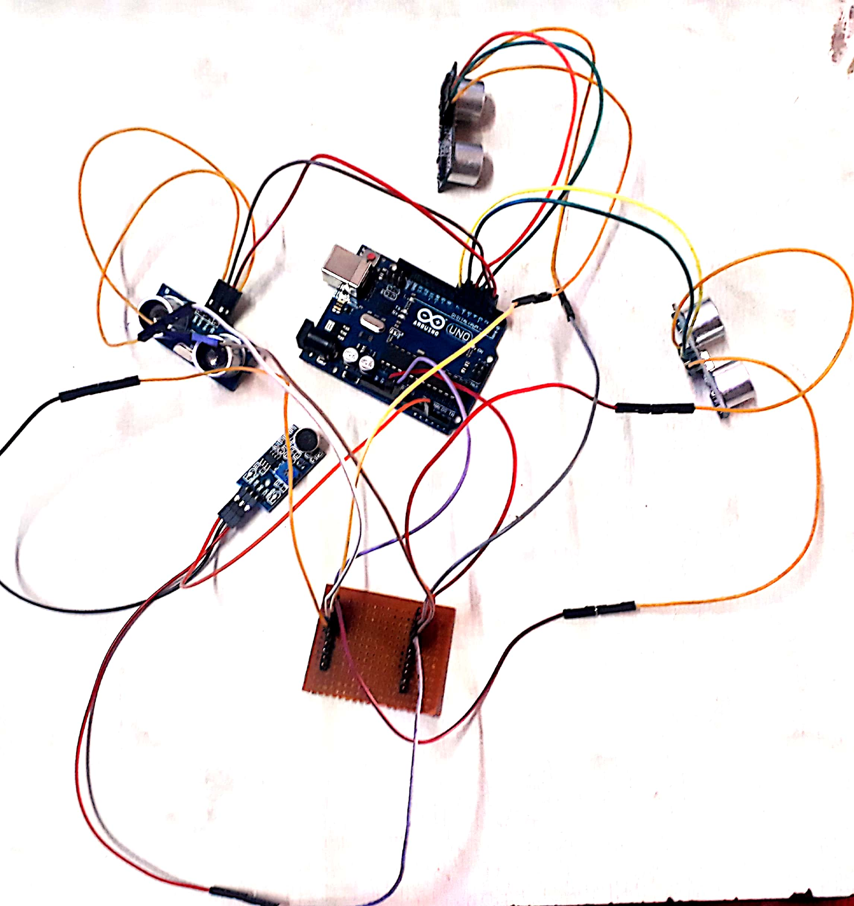

Construction

Common connections : Ground pin connection
5V pin connection

Output Connection :
Soundpin = A2

Step 3: Connect all three vibrators.

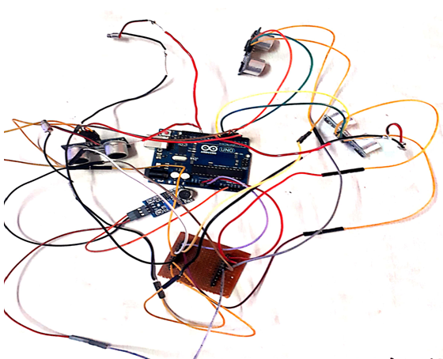

Construction

Coomon connections : Ground pin connection
Output connection : vib1= D9
vib2= D10
vib3= D11
3.4. Work Flow

The Ultrasonic sensor i.e. fixed on the three sides(left,back,right)on the helmet detects the obstacle(vehicle) using the ultrasonic waves.

From the emitted ultrasonic waves we can measure the distance between the obstacle(vehicle)and the person with helmet

Eventually we can sense the sound from the surroundings especially from the horn and its decibel is taken into account

From the distances measured by the three ultrasonic sensors (8 different test cases),the minimum distance is chosen for further process

The minimum distance is compared with the threshold value.

Similarly the detected sound decibel is also compared with the threshold value

Based on the comparisons the final alert is given as vibration using vibrating motor in the respective sides(4 different cases)

Table.3.4(a) Testcases for measuring the obstacles

Test cases | Ultrasonic sensor1  (Left)  Output  (in cms) | Ultrasonic sensor 2 (Back)  Output  (in cms) | Ultrasonic sensor 3 (Right)  Output  (in cms) | Compare the distance(d) measured & find direction & d_{min} (in cms)
Test case 1 | 100 | 150 | 170 | 100 (Left)
Test case 2 | 150 | 100 | 170 | 100 (Back)
Test case 3 | 170 | 150 | 100 | 100 (Right)
Test case 4 | 100 | 100 | 100 | 100 (Back)
Test case 5 | 100 | 100 | 150 | 100 (Back)
Test case 6 | 100 | 100 | 90 | 90 (Right)
Test case 7 | 100 | 150 | 100 | 100 (Right)
Test case 8 | 100 | 50 | 100 | 50 (Right)

Table.3.4(b) Comparison table

Sound threshold  >Ts=800 | Ultrasonic value  <Tu=200 | Output
400 | 100 | High
850 | 100 | High
850 | 250 | Low
600 | 250 | Low

4. Source code
constint pingPin1 = 3; // Trigger Pin of Ultrasonic Sensor
constint echoPin1 = 2; // Echo Pin of Ultrasonic Sensor
constint pingPin2 = 5; // Trigger Pin of Ultrasonic Sensor
constint echoPin2 = 4; // Echo Pin of Ultrasonic Sensor
constint pingPin3 = 7; // Trigger Pin of Ultrasonic Sensor
constint echoPin3 = 6; // Echo Pin of Ultrasonic Sensor
constint vib1 = 9; // vib and soundpin are not changed throughout the process
constint vib2 = 10; // vib and soundpin are not changed throughout the process
constint vib3 = 11; // vib and soundpin are not changed throughout the process
constintsoundpin = A2;
//constintthershu=22400; // sets threshold value for Ultrasonic sensor
//constintthershss=1050; // sets threshold value for sound sensor

void setup() {
Serial.begin(9600);
pinMode(soundpin, INPUT);
pinMode(vib1, OUTPUT);
pinMode(vib2, OUTPUT);
pinMode(vib3, OUTPUT);

// Starting Serial Terminal
}

void loop() {
long duration1, duration2, duration3, inches, cm, tempu, threshu = 22400;
intthreshss = 1050;
pinMode(pingPin1, OUTPUT);
digitalWrite(pingPin1, LOW);
delayMicroseconds(2);
digitalWrite(pingPin1, HIGH);
delayMicroseconds(10);
digitalWrite(pingPin1, LOW);
pinMode(echoPin1, INPUT);
duration1 = pulseIn(echoPin1, HIGH);
inches = microsecondsToInches(duration1);
cm = microsecondsToCentimeters(duration1);
Serial.println(duration1);
Serial.print(inches);
Serial.print("for sensor 1 in, ");
Serial.print(cm);
Serial.print("cm");
Serial.println();
delay(1000);
pinMode(pingPin2, OUTPUT);
digitalWrite(pingPin2, LOW);
delayMicroseconds(2);
digitalWrite(pingPin2, HIGH);
delayMicroseconds(10);
digitalWrite(pingPin2, LOW);
pinMode(echoPin2, INPUT);
duration2 = pulseIn(echoPin2, HIGH);
inches = microsecondsToInches(duration2);
cm = microsecondsToCentimeters(duration2);
Serial.print(inches);
Serial.print("for sensor 2 in, ");
Serial.print(cm);
Serial.print("cm");
Serial.println();
delay(1000);
pinMode(pingPin3, OUTPUT);
digitalWrite(pingPin3, LOW);
delayMicroseconds(2);
digitalWrite(pingPin3, HIGH);
delayMicroseconds(10);
digitalWrite(pingPin3, LOW);
pinMode(echoPin3, INPUT);
duration3 = pulseIn(echoPin3, HIGH);
inches = microsecondsToInches(duration3);
cm = microsecondsToCentimeters(duration3);
Serial.print(inches);
Serial.print("for sensor 3 in, ");
Serial.print(cm);
Serial.print("cm");
Serial.println();
delay(1000);

intsoundsens = analogRead(soundpin);
Serial.println(soundsens);

if (duration1 < duration2 && duration1 < duration3)
tempu = duration1;
else if (duration2 < duration1 && duration2 < duration3)
tempu = duration2;
else if (duration3 < duration1 && duration3 < duration2)
tempu = duration3;
else if ((duration1 == duration2) && (duration2 == duration3))
tempu = duration2;
else if ((duration1 == duration2) && (duration2 < duration3))
tempu = duration2;
else if ((duration1 == duration2) && (duration2 > duration3))
tempu = duration3;
else if ((duration1 == duration3) && (duration2 < duration3))
tempu = duration2;
else if ((duration1 == duration3) && (duration2 > duration3))
tempu = duration3;

if ((tempu<threshu) && (soundsens>threshss)) {
if (tempu == duration1) {
digitalWrite(vib1, HIGH); //turns led on
delay(1000);
digitalWrite(vib1, LOW); //turns led on
} else if (tempu == duration2) {
digitalWrite(vib2, HIGH); //turns led on
delay(1000);
digitalWrite(vib2, LOW); //turns led on

} else {
digitalWrite(vib3, HIGH); //turns led on
delay(1000);
digitalWrite(vib3, LOW); //turns led on
}
} else if ((tempu<threshu) && (soundsens<threshss)) {
if (tempu == duration1) {
digitalWrite(vib1, HIGH); //turns led on
delay(1000);
digitalWrite(vib1, LOW); //turns led on
} else if (tempu == duration2) {
digitalWrite(vib2, HIGH); //turns led on
delay(1000);
digitalWrite(vib2, LOW); //turns led on

} else {
digitalWrite(vib3, HIGH); //turns led on
delay(1000);
digitalWrite(vib3, LOW); //turns led on
}
} else if ((tempu>threshu) && (soundsens<threshss)) {

if (tempu == duration1) {
digitalWrite(vib1, LOW); //turns led on
delay(1000);
} else if (tempu == duration2) {
digitalWrite(vib2, LOW); //turns led on
delay(1000);
} else {
digitalWrite(vib3, LOW); //turns led on
delay(1000);
}
} else if ((tempu>threshu) && (soundsens>threshss)) {
if (tempu == duration1) {
digitalWrite(vib1, LOW); //turns led on
delay(1000);
} else if (tempu == duration2) {
digitalWrite(vib2, LOW); //turns led on
delay(1000);
} else {
digitalWrite(vib3, LOW); //turns led on
delay(1000);
}
}
}
longmicrosecondsToInches(long microseconds) {
return microseconds / 74 / 2;
}
Longmicr osecondsToCentimeters(long microseconds) {
return microseconds / 29 / 2;
}

5. Future enhancement
- To distinguish and sense horn sound for separate vehicle using Bayesian classification.
- To detect obstacle from 360 degree and sense sound separately.

5.1 Other aspects
- Obstacle alert stick for blind people.
- Wearable belt for pedestrians.

6. Conclusion
We mapped our idea to a prototype which sense the horn and alert the hearing impaired person in the form of vibration. We will update our Smart Helmet prototype to the next version with the future enhancement mentioned above.

7. Reference
https://acadpubl.eu/hub/2018-119-12/articles/6/1346.pdf
https://create.arduino.cc/projecthub/iotboys/control-led-by-clap-using-arduino-and-sound-sensor-e31809

